System modelling

Model types

Context models

Process models

Behavioural models

data-processing models

DFD

state machine models

statecharts

**System modelling**

Different models present the system from different perspectives

• External perspective showing the system’s context or environment;

• Behavioural perspective showing the behaviour of the system;

• Structural perspective showing the system or data architecture.

**Model types**

数据过程模型 Data processing model showing how the data is processed at different stages

组成模型 Composition model showing how entities are composed of other entities

结构模型 Architectural model showing prinicipal sub-systems

定义模型 Classification model showing how entities have common characteristics

状态图 Stimulus/response model showing the system's reaction to events

**上下文模型 Context models**

context models are used to illustrate the operational context of a system - they show what lies outside the system boundaries

social and organisational concerns may affect the decision on where to position system boundaries

Architectual models show the system and its relationship with other systems

eg ATM system

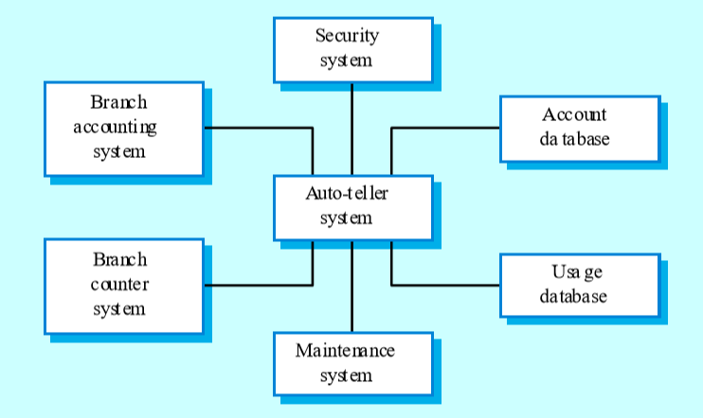

**Process models**

process models show the overall process and the processes that are supported by the system

data flow models may be used to show the processes and the flow of information from one process to another

eg Equipment procurement process

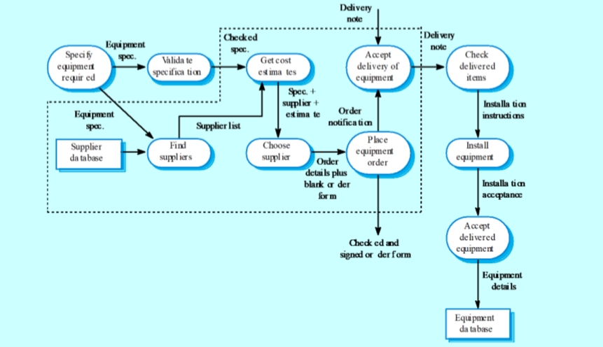

**Behavioural models**

behavioural models are used to describe the overall behaviour of a system

two types of behaviour are:

data processing models that show houw data is processed as it moers through the system;

state machine models that show the systems response to events

these models show different perspectives so both of them are required to describe the system's behaviour

**data-processing models**

data flow diagrams(DFDs)may be used to model the system's data processing

these show the processing steps as data flows through a system

DFDs are an intrinsic part of many analysis methonds

Simple and intuitive notation that customers can understand

show end-to-end processing of data

**DFD**

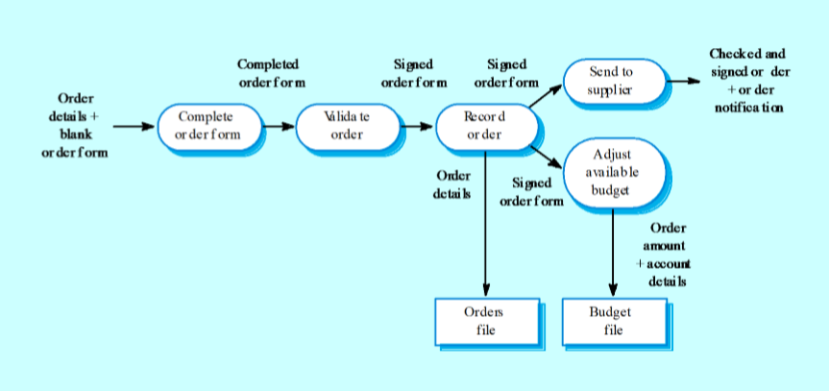

DFDs model the system from a functional perspective

tracking and documenting how the data associated with a process is helpful to develop an overall understanding of the system

data flow diagrams may also be used in showing the data exchange between a system and other systems in its environment

eg insulin pump dfd

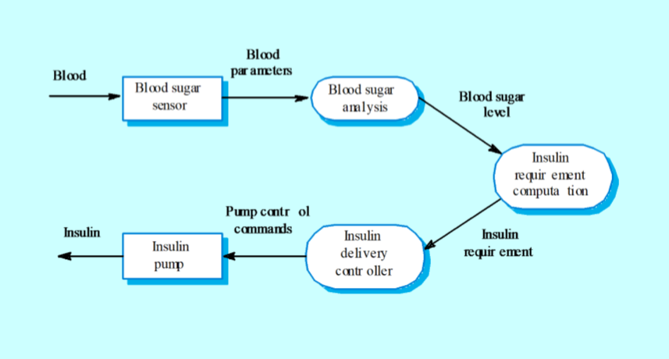

**state machine models**

these model the behaviour of the system in response to external and internal events

they show the system's responses to stimuli so are often used for modelling real-time systems

state machine models show system states as nodes and events as arcs between these nodes.when an event occurs, the system moves from one state to another

statecharts are an integral part of the uml and are used to represent state machine models

**statecharts**

allow the decompositio of a model into sub-models

a brief description of the actions is included following the 'do' in each state

can be complemented by tables describing the states and the stimuli

eg.microwave oven model

